МБОУ СОШ № 45

*Тема урока: «*Антарктида сегодня и завтра**»**

9 класс

SPOTLIGHT

Ю.Е. Ваулина, В Эванс, Дж. Дули, О.Е. Подоляко

Работу выполнила: Тимраляева Назира Габасовна,

учитель английского языка

ПЕРЕВЕДИ

\

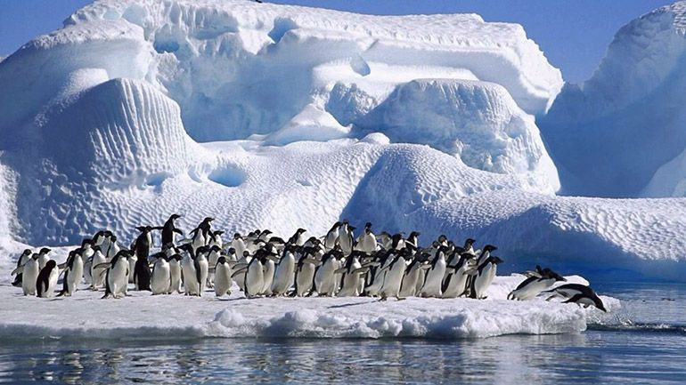

Antarctica is one of the six continents of the Earth, which is located in the southern hemisphere. The continent is washed by three oceans - the Atlantic, Pacific and Indian. Many small islands adjoin it, thus forming part of the world. a large piece of ice and stone. Antarctica is a huge piece of ice. There is a constant permafrost, a huge number of penguins live, sometimes you can find rare plant species that have adapted to low temperatures.

Antarctica is the highest place on earth. In addition to the eternal cold, there is observed the lowest humidity on the planet, the strongest winds and solar radiation. This continent has long attracted the interest of scientists around the world. The mainland does not belong to any of the states, there can only be scientific research. Most of the continent is covered with a thick layer of ice. In places, there are dry elevations, volcanoes, mountains, valleys, which are located above the surface of the ice cover. Under the ice also has its own relief, which mainly consists of mountain ranges.

On the mainland there is the largest crater on the planet. There is a hypothesis that 250 million years ago a huge asteroid fell to Earth, forming this crater. With the fall of the asteroid exploded, and from the dust on the cosmic body led to a long cooling. All plants and animals of that era died. Scientists have long discovered remains of plants and birds of the time in the glacial layers.

In winter, the temperature on the mainland reaches minus 80 ° C, (centigrade), in summer - minus 40 °C. On the coast, summer temperatures can be above zero to 5 degrees. Melting of ice begins. At the time of global warming, small trees had appeared on the mainland forming tundra. The land, which has no ice, is covered with moss and lichen, mushrooms and algae. On the coast you can meet seals and penguins.

**.**

**-The lesson is over. Goodbye!**